# SRTSweb

There are several benefits in using SRTSweb in the medical readiness field. Because SRTSweb is a web-based application it eliminates the need for client application software, satisfies the Tri-Service Information Assurance (IA) requirements, and provides the user with a state-of-the-art tool to accomplish the mission. Users can go to any computer and log in to SRTSweb.

Additionally, there is no application specific hardware to maintain, no software to install, and no application software updates. There will be little or no impact to the user during server upgrades, maintenance, or back-ups. The user will type in an address in the URL field of an Internet browser, or save it to their Favorites drop-down menu in their Internet browser for easy access. SRTSweb ends the need for the application to be hosted and managed at each clinic location. This action is accomplished by centralized servers that provide for less local site management in support of the application, resulting in reduced support requirements on the end users.

The Lab users have no packets to email or download. Orders go directly to the lab from the clinics.

# LOGGING INTO SRTSweb

<https://srtsweb.amedd.army.mil/>

Type in the SRTSweb URL to access the application. The first screen displayed in the application is the SRTSweb User Agreement screen. Read and accept the SRTSweb User Agreement to proceed.

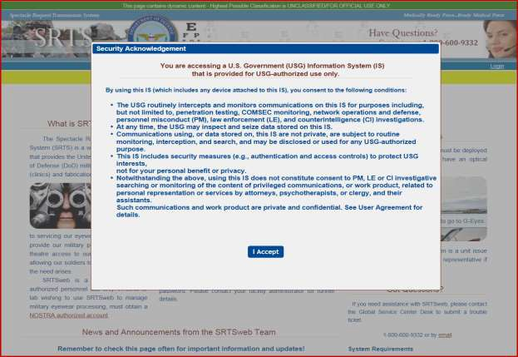

The screen will display the welcome and log in screen of SRTSweb.

If the lab admin added the user with their DOD, the user can log in with their CAC.

Select the option to login: CAC/PIV Login and click Login.

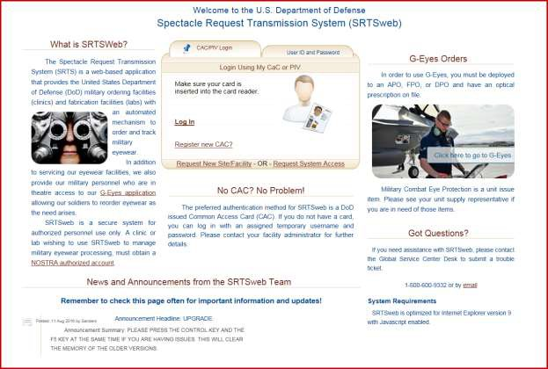

Select the DOD Email Certificate to log as a Lab Tech or Lab Clerk.

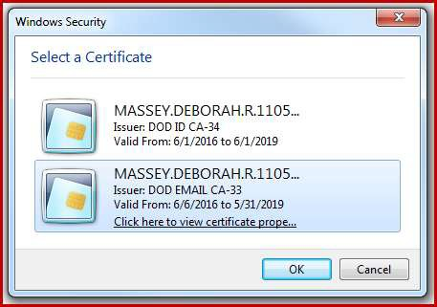

Press OK.

After selecting the proper CAC certificate to access the application the user must acknowledge the Rules of Behavior / Acceptable Use Policy screen. To continue using the system, the users will only have to click this acknowledgment once annually.

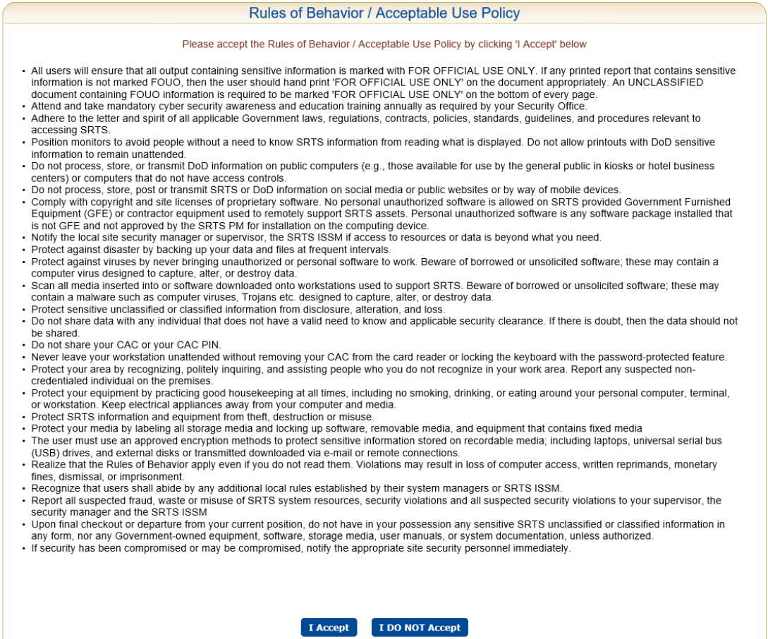

* Click I Accept

You can access additional Information and Resources at the bottom of the page. The patient does not have to log into SRTSweb to access these resources.

The screen has a **Check Order Status** for patients from the clinic to track their orders.



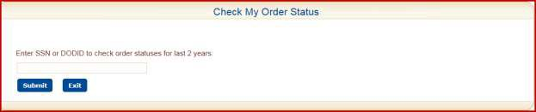

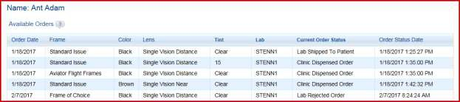

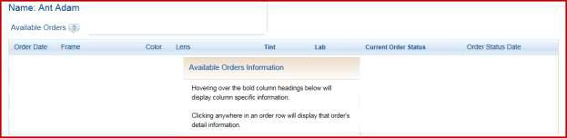

The screen also has a short cut for NOSTRA Web Site.



Support for customers of the SRTSweb system will come directly from SRTSweb team members located at DHA Clinical Solutions – Army South. The request for support should be submitted via the Global Service Center Desk located at DHA.

For assistance with SRTSweb, please contact the Global Service Center Desk by phone at 1-800-600-9332 or by email at: [dhagsc@mail.mil](mailto:dhagsc@mail.mil) to create a support ticket.

This link is located on the log in page.

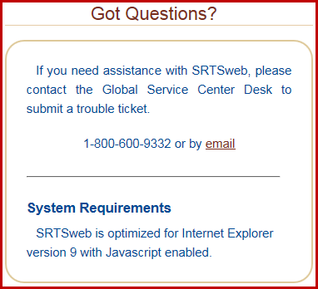

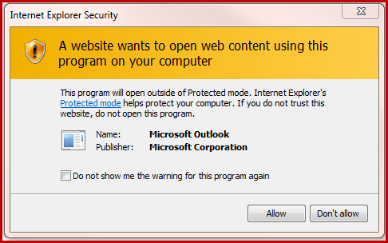

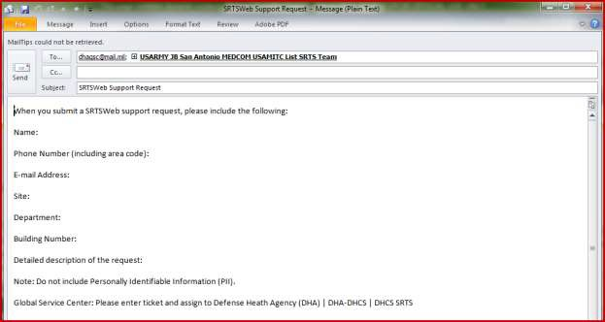

Lab clerk or tech users have a session time out of 15 minutes.

Users will see a 5 minute Logout Warning at the 10 minute warning. Pressing anywhere on the screen will continue the session for the user.

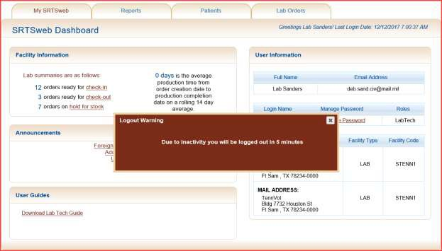

Users will automatically be logged out if the screen is not touched either at the 5 minute warning or within 15 minutes.

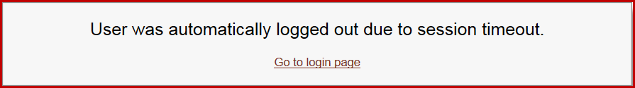

Users will have the following message if the Logout is pressed to exit the application.

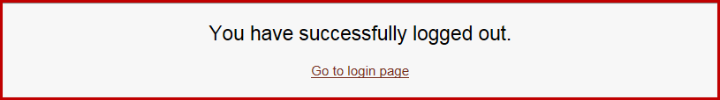

# SRTSweb Dashboard

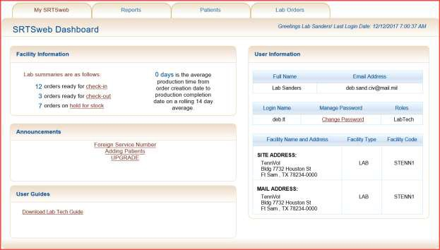

Once logged into the system as a user with Lab Tech privileges, the screen contains a title bar, and a menu of tabs: My SRTSweb, Reports, Patients, and Lab Orders. On the right side of the title bar is a link to logout of the SRTSweb application.

The dashboard shows the current Username. The dashboard also shows the user with the last successful login date and time prior to the current log on session on the right.

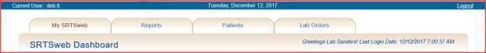

Directly below the tabs, the SRTSweb Dashboard is displayed. The Dashboard can also be accessed by selecting the My SRTSweb tab from anywhere in the application. The Dashboard can also be accessed by pressing the SRTSweb logo.



The Dashboard is composed of 4 sections: Facility Information, Announcements, User Guides and User Information.

# Facility Information

On the left side of the Dashboard, a section called “Facility Information” is displayed which contains three tabs.

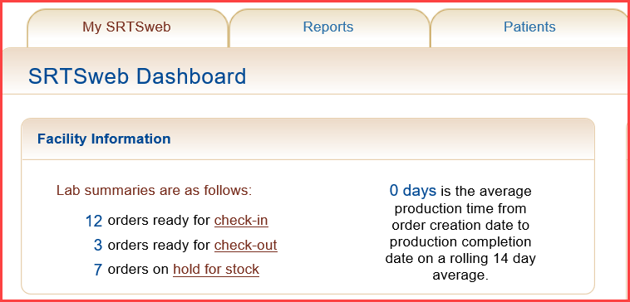

# Lab Summaries

The Lab Summaries section shows totals of the orders awaiting check-in and check-out. SRTSweb will display a rolling 14 day average production time from order creation date to production completion date.

Each of the summary data lines provides a short-cut to the application sections as accessed by the tabs at the top of the screen. Clicking on the word check-in will take you to the **Lab Orders -> Manage Orders -> Check-In Orders** screen. Clicking on word check-out will take you to the **Lab Orders -> Manage Orders -> Dispense Orders** screen. Clicking on word hold for stock will take you to the **Lab Orders -> Manage Orders -> Hold for Stock** screen.

# Announcements

Announcements can be viewed from this screen. The same message can be viewed under My SRTSweb - My Message Center.

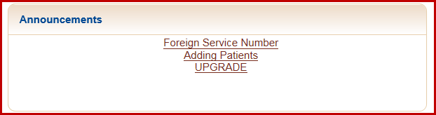

# User Guides

For users logging in with the Lab Technician role the User Guide can be downloaded from this screen.

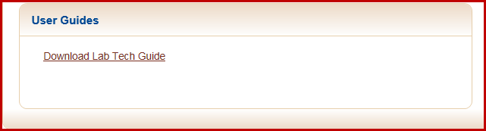



# User Information

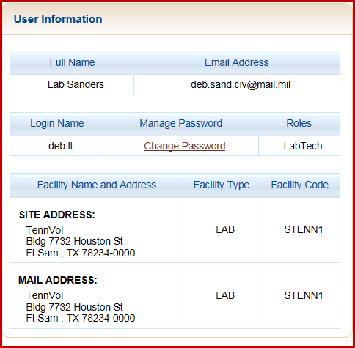

On the right side of the Dashboard is the profile information section which displays user profile information. Included in the login information is the user’s Full Name, Email Address, Login Name, a link to Manage Password and the user’s assigned Role(s).

This section also contains the Facility Name and Address, Facility Type, Facility Code and user’s mailing address.

The site administrator is the only user who can update the user demographic and login information except for login name.

Press My SRTSweb to go back to dashboard.

User can also press on the SRTSweb logo at the top on the left from anywhere in the app to return to dashboard.



# My SRTSweb

If the mouse pointer hovers above the My SRTSweb tab, a drop down menu appears for three process modules: My Message Center and Release Notes.

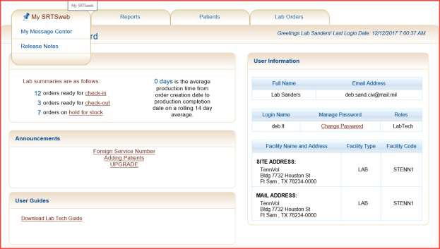

To access announcements or messages click on the **My Message Center** option. To access the Release Notes click on the **Release Notes** option.

# My Message Center

Messages and Announcements can be viewed by clicking My Message Center on the My SRTSweb drop down menu. They can be viewed on the left under Summaries on the SRTSweb Dashboard screen.

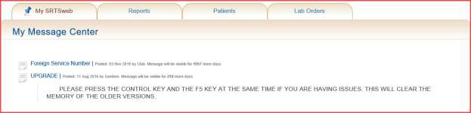

These messages can be from the Lab Admin, Clinic Admin or SRTSweb.

# Release Notes

To view release notes for the current SRTSweb version, select Release Notes from the My SRTSweb drop down menu.

Users can also click on the version number at the bottom of the Dashboard screen to see release notes. Release Notes are updated at every update or fix in the system.

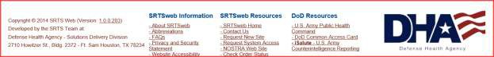

To go back to dashboard press either the back arrow or the link SRTSweb Home at bottom of page.

User can also press on the SRTSweb logo at the top on the left from anywhere in the app to return to dashboard.



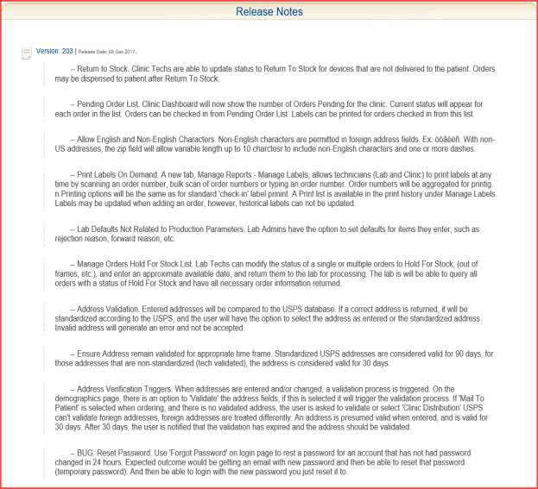

A "**Quick Search**" feature has been implemented to allow searching orders and searching patients from anywhere within SRTSweb. The field and button are anchored to the top of the page on the right. The user may enter an order number (including the dash), an SSN, or a DOD ID number into the field and click Go.

The system will interpret the input data and take the user to the correct screen. This feature will be discussed more in the Lab Order section.

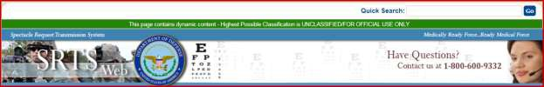



# Reports

**Manage Reports**

Depending on which role the lab user is assigned, a set of reports will be displayed as a drop down list in the Select a Report to View field.

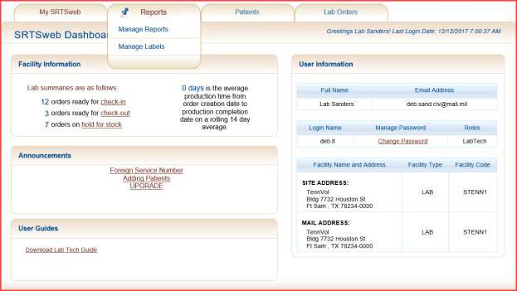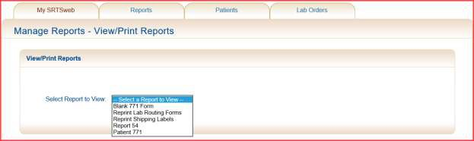

To view a report select the From Date and the To Date by selecting a date from the calendar or by entering a date range. Dates entered manually must in be format: *mm/dd/yyyy.*

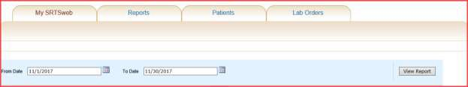

To save or print the report, move the mouse pointer above the Export drop down menu and select the file type desired from the drop down list. The user is asked to choose between opening the report and saving it. If opening the report, the Adobe program (Adobe Reader, Adobe Acrobat, or Adobe PDF Converter) can be used to display the report. If the report is to be saved to disk, it will be downloaded to the user’s PC.

Once the selected report is displayed it can be saved in these formats:

* XML file
* CSV file (comma delimited)
* PDF
* MHTML (web archive)
* Microsoft Excel file
* TIFF file
* Microsoft Word file

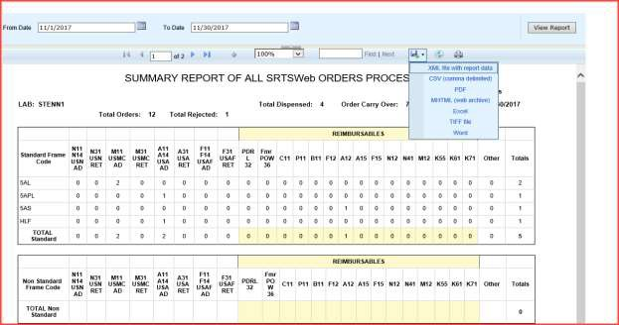

The user can open, save or cancel the report.



To print the report, open the saved report you want to print, choose File, select Print. Report samples can be viewed in the last pages of the SRTSweb User Guide.

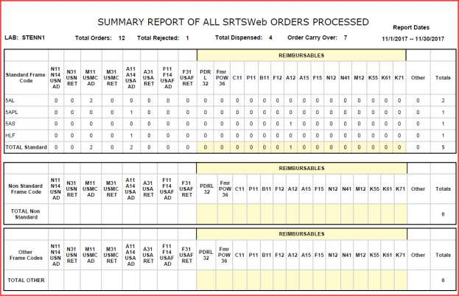

# Manage Labels

Manage labels gives the user the ability to add order numbers that have not been marked as a MTP (mail to patient) order.

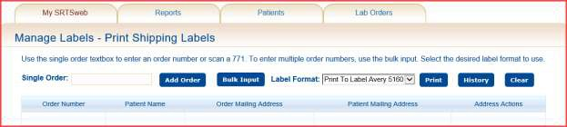

The user has the ability to add orders that were not marked as Mail to Patient by typing, scanning in a single order number and pressing **Add Order** or **Bulk Input** and Add.

User must type in order number and press Add Order.

The user has the ability to select patient order address or mailing address.

# NOTE: Orders must be printed to pull up in History.

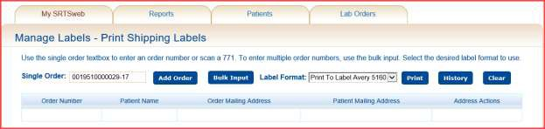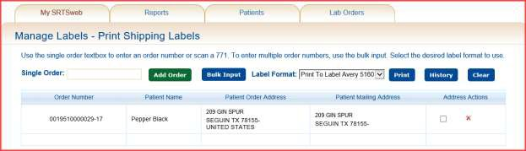

**PATIENTS**

**Patient Search**

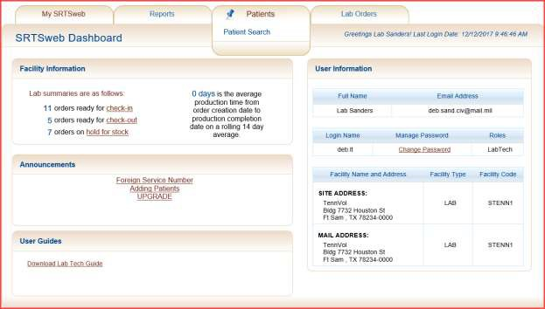

Within the Lab module of SRTSweb, users are able to search and view patient records, depending on the user’s role. Patient Information is not updatable from within the Lab module of the application. SRTSweb will maintain patient data for 4 years after which the records are migrated to an archive database.

The user can search patient records using a variety of search criteria, or combinations of:

* a portion or all of the patient’s last name
* the patient’s identification number or SSN

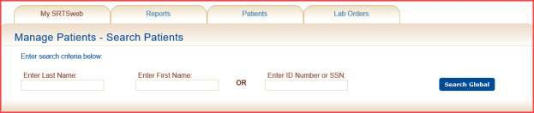

The button on this screen allows the user to do a Global Search that includes all sites, using the specified criteria.

If no specific patient identifiers are entered, no patient records are returned in the record set.

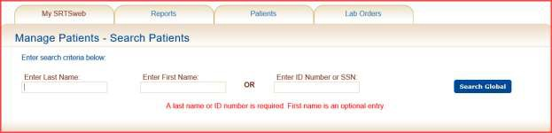

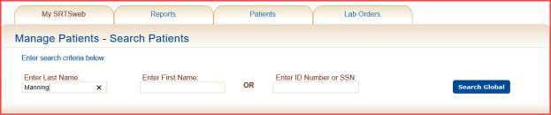

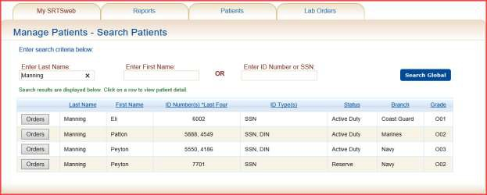

The search results have a sorting capability added to the columns.

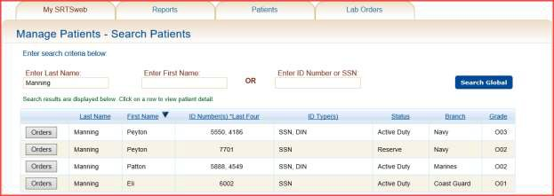

The user has the capability to click on a patient name and be taken to the patient’s information page to research patient or order information.

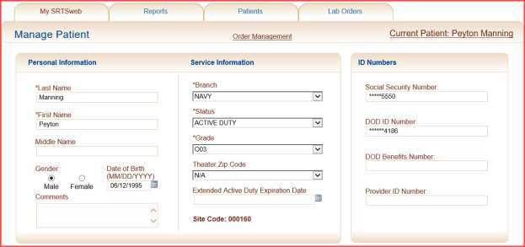

The user can click on the **Orders** button in front of the patient’s name and pull up all orders.

This is an information screen only; only Lab Received orders can be updated.

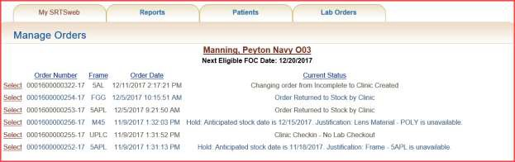

The results of the search are then displayed and the user has the option to view more detail by clicking on the patient’s name bringing up the patient’s personal and contact information.

The user can also click on the Order Management on the Patient Information page to pull up the ordering status if the patient has an order on file.

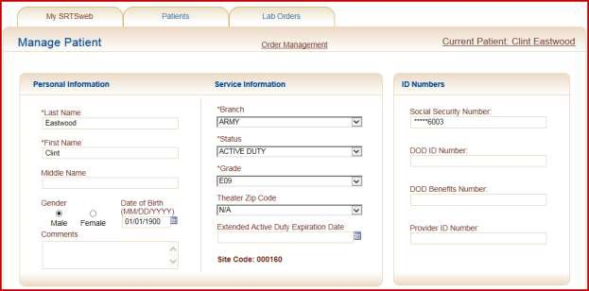

The Patient Order Management screen displays patient information and order information stored in the SRTSweb database. This information includes:

* Order Number
* Frame
* Order Date
* Current Status of the order

The user can click on an order by pressing Select. The user can click on an order that has a current status of **Lab Received** and pull up the order. The user can Reject, Redirect order or Hold for Stock by selecting option. This will be discussed more in the Lab Processing section.

# NOTE: A visual indicator has been added to the right of Order Number (above the technician’s name) to allow user to view the uploaded prescription document.

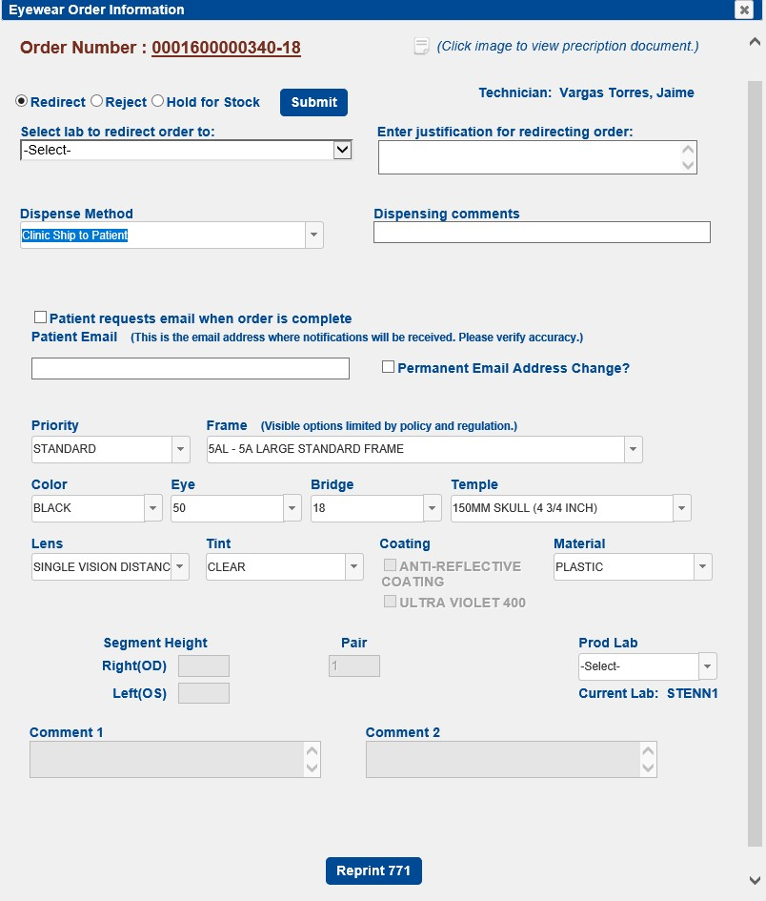

# LAB ORDERS

Hovering on the Lab Order tab will display Lab Order Management.

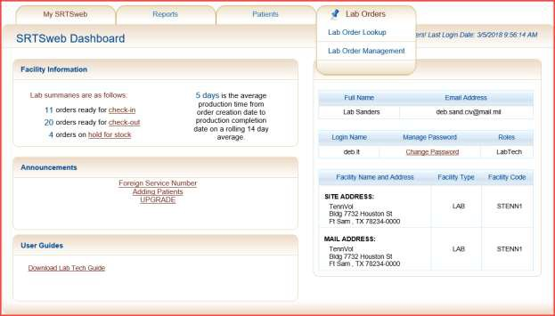

Clicking on Lab Order - Lab Order Lookup gives the user the option to search a patient using Last name and/or First name.

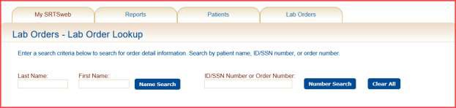

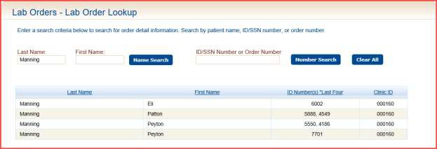

Clicking on Lab Orders - Lab Order Management brings the Check In and Dispense tabs.



The user can access these three tabs from the dashboard also.

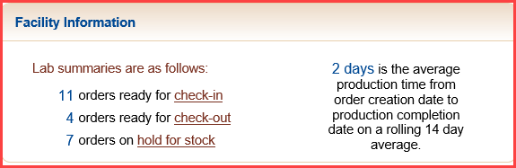

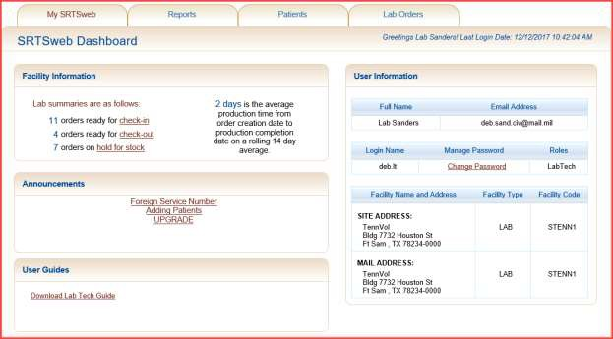

The Lab module user may process an order to:

* check-in the order
* check-out (dispense the order)
* redirect the order
* reject the order
* hold for stock
* check in hold for stock

# NOTE: A lab order cannot be further processed until the order has been checked-in.

**Manage Orders - Check-In**

This module is provided for optical fabrication laboratories that do not use software called a Lens Management System (LMS). Labs that **do** use a LMS will have the receiving orders checked-in automatically when the orders are transmitted to them electronically.

When an order has been created by the clinic or redirected to a specific lab, the receiving lab user is notified that orders are ready for **check-in** on the SRTSweb Dashboard. The user with role privileges allowing order check-in may either select Lab Orders -> Lab Order Management -> Check-In or click the **check-in** link from the SRTSweb Dashboard to access the process to check-in orders.

The Lab Orders Management – Check-In screen is displayed showing how many orders are awaiting check-in. Total Selected Orders will update as order number is selected.

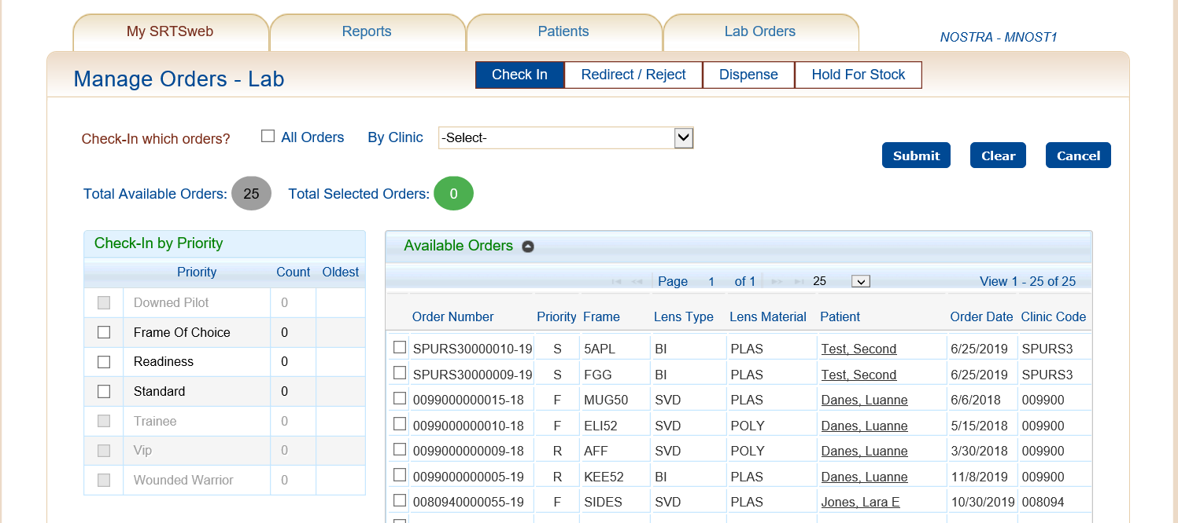

The Site Code can be added to search for a specific site.

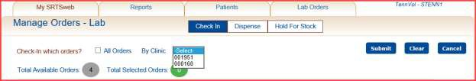

When the user selects the **By Clinic** and selects a site code **all orders from that site**

will be marked to check in.

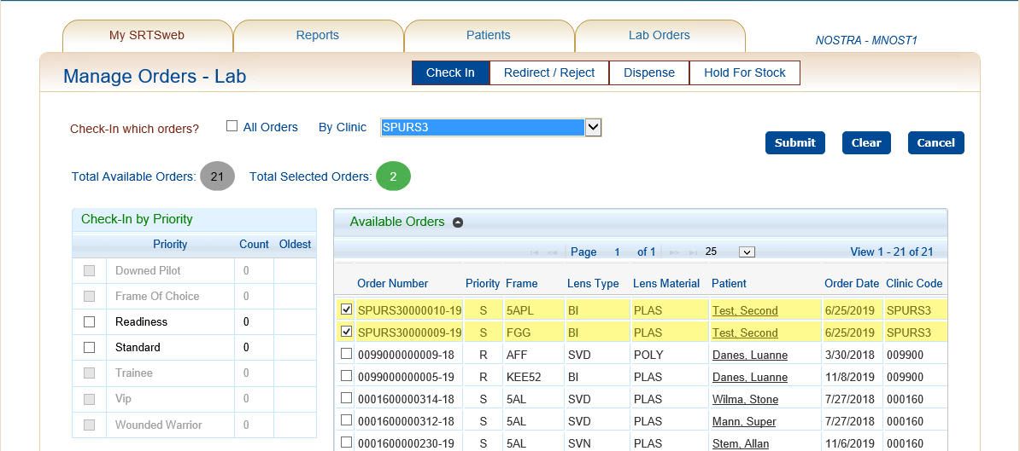

When the user selects the **All Orders** all the orders will be marked to check in.

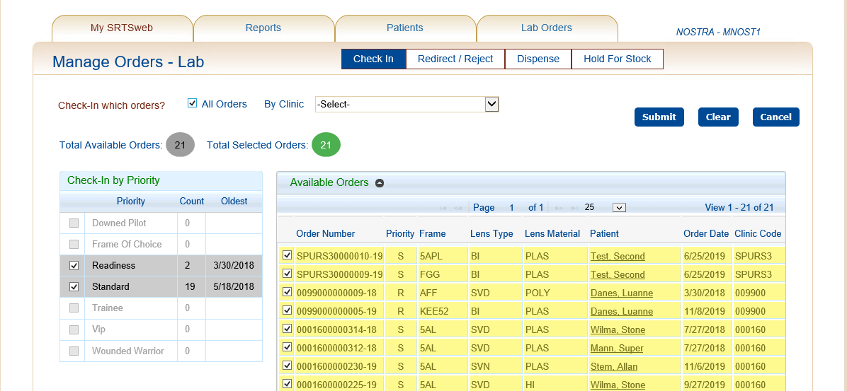

The user may select by Priority by checking the box (left side of the screen) indicating the priority to print. Next to each priority selected you will find the number of Orders and the Date of the oldest order to be printed.

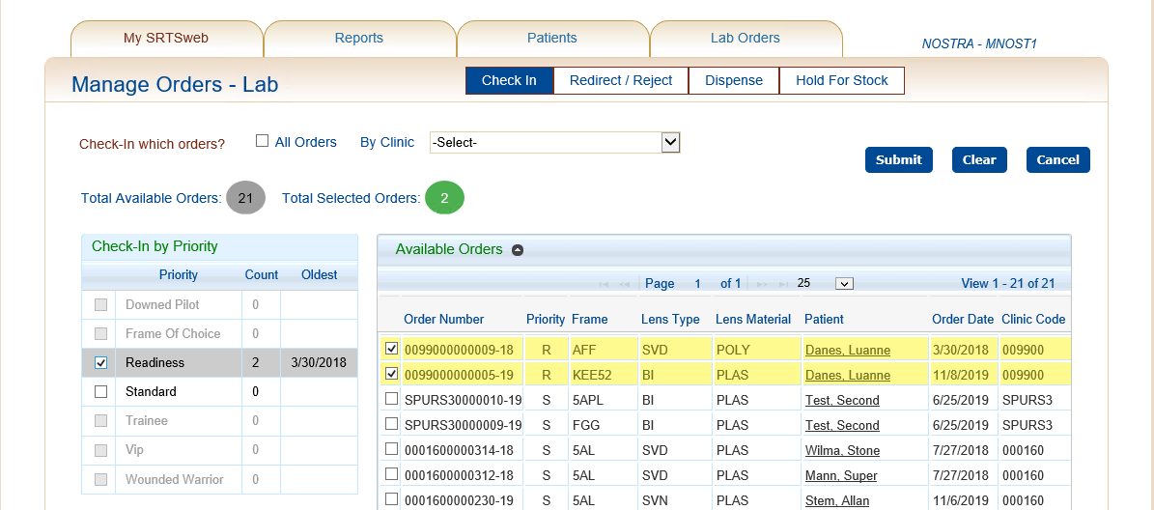

The Check-In process will mark the orders as delivered to the lab for production**. An order must be checked-in before further processing can occur.** If an order is not checked-in, it will remain in order records file but no other action can be taken on the order. The user must click on the button to mark the order as checked-in.

The user must press **Submit** after orders are marked for check in. Pressing **Clear** or

**Cancel** will not check in orders.

After checking in orders the screen will give you the option to Open, Save, Save As, Save and Open or Cancel the print of the DD Form 771.



The DD Form 771 will open in a PDF format.

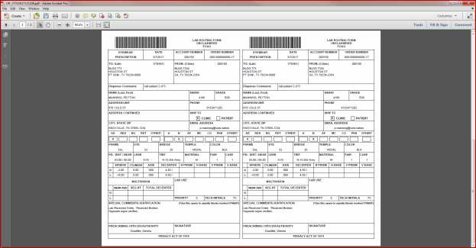

The user has the option to print, save, email.

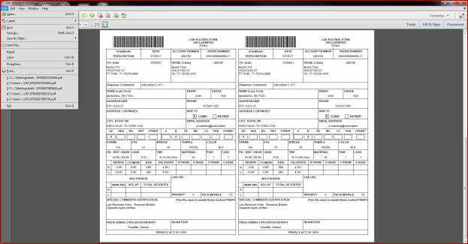

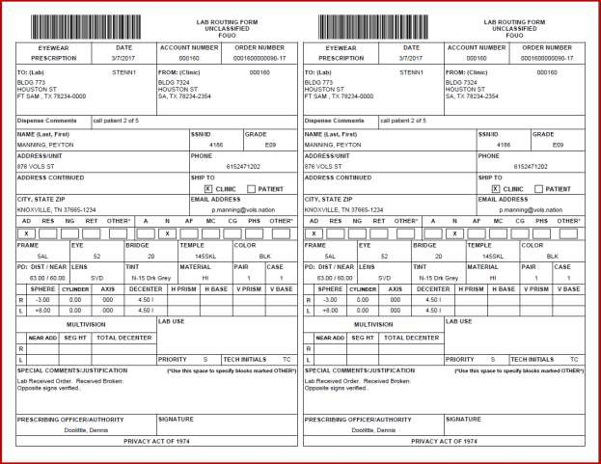

The user has the option to save before closing the pdf.

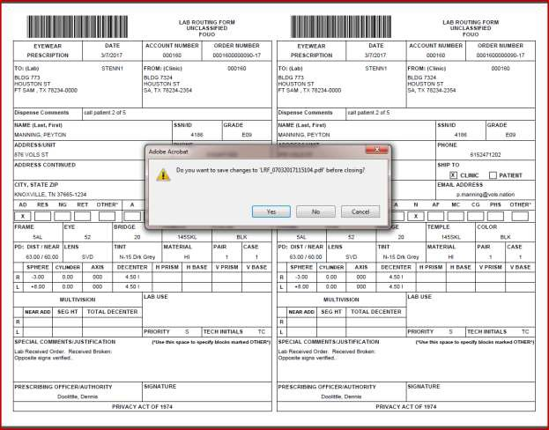

The displayed orders can then be saved to the user’s local disk and printed. This information is used to produce the orders. The lab will review each order and determine whether or not the order is complete and if the lab has the necessary components to produce the order as documented.

The user can reprint the DD 771 from the Reports - Manage Reports – Reprint Lab Routing Forms for the past 7 days.

The user can also reprint the mailing labels from the Reports - Manage Reports – Reprint Shipping Labels for the past 7 days if the lab ships to patients.

**Single Orders:** After checking in the order the user has the ability to **Redirect, Reject or Hold For Stock** a single order.

The lab can redirect, reject or hold for stock an order, document the reason and submit the order for further processing by either the next lab or the originating clinic. If the lab cannot fulfill the order for any reason then they will take the appropriate action on this page and the clinic will be notified that they either have a problem order that needs their attention, a redirected order, that they have an order ready for processing or an order is on hold.

This process can be done in two ways.

Search for the patient’s name under Patients – Patient Search.

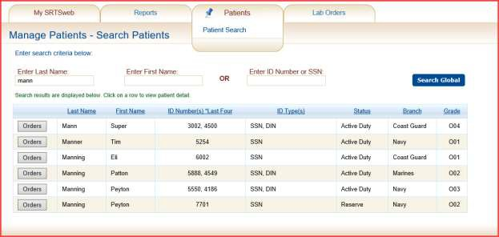

Select on the word **Orders** or after clicking on patient’s name open the **Order Management** link.

A list of orders that the patient has on file will be displayed. Select the order number.

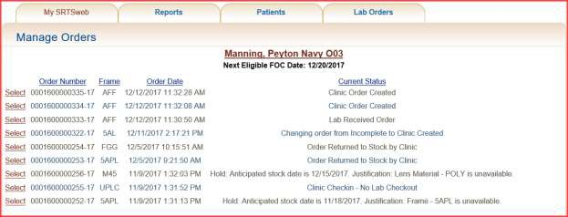

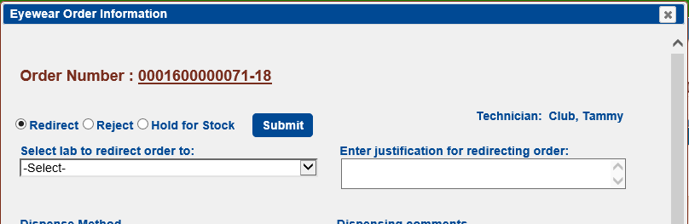

A "**Quick Search**" feature has been implemented to allow searching orders.

The user can pull up the order by typing in the order number in the **Quick Search** at the top right corner. This action will take the user directly to the order without having to select from the list of orders on file.







If the order is to be redirected, select another lab from the dropdown list.

A multi-vision order cannot be redirected to a single vision lab. A single vision lab can be redirected to a multi-vision lab.

The Laboratory field cannot be changed unless the order is being redirected.

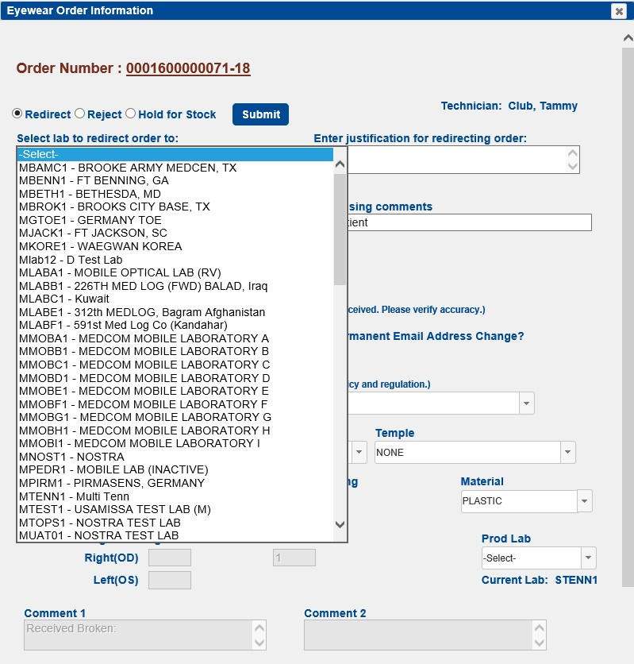

If the order is to be redirected, enter a justification for redirecting the order. Press Submit.

## NOTE: The admin user can default a justification for redirecting and rejecting. The comment can be changed by user.

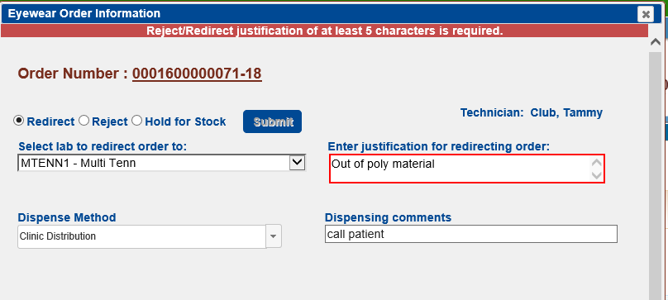

If the order is to be rejected, enter a justification for rejecting the order. Press **Submit**.

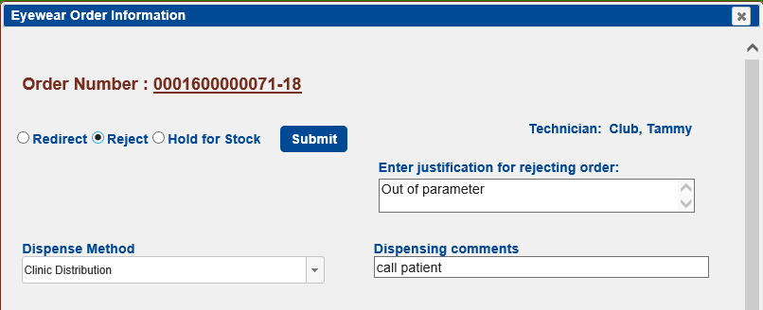

The rejection notice will be send back to the requesting clinic.

If the order is to be put Hold for Stock

* Select Estimated Stock Date
* Select Out of Stock Reason

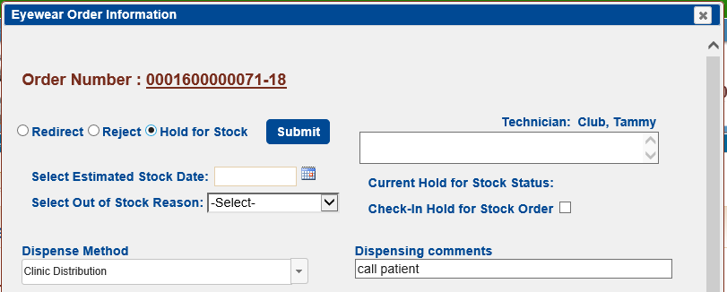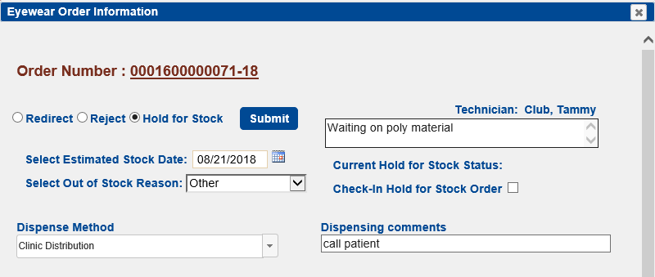

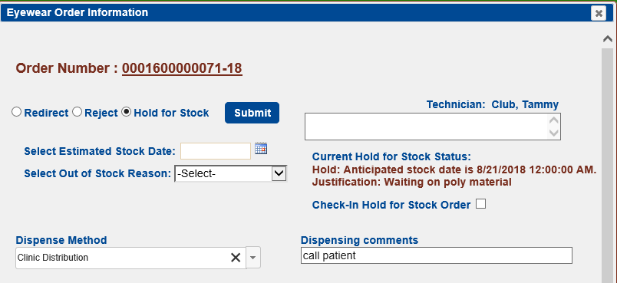

The new status will be sent back to the requesting clinic.

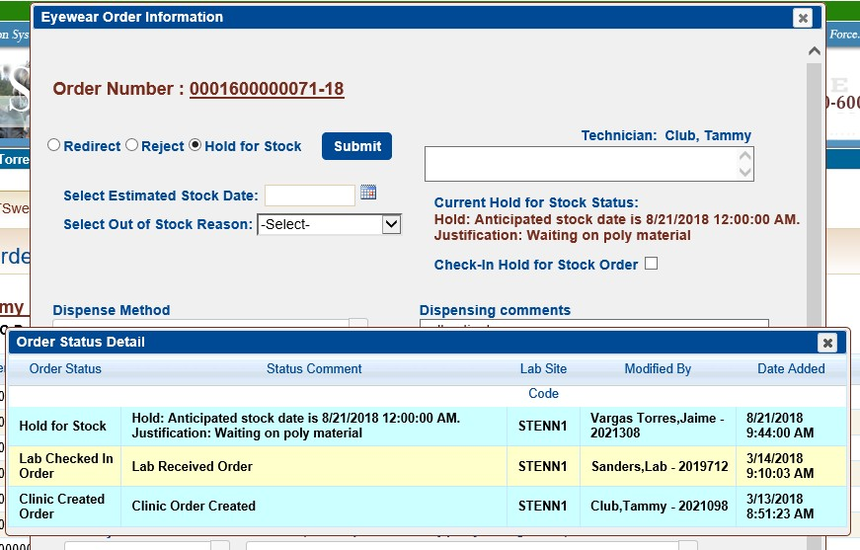

When the Anticipated stock date is changed a new status is sent to the requesting clinic.

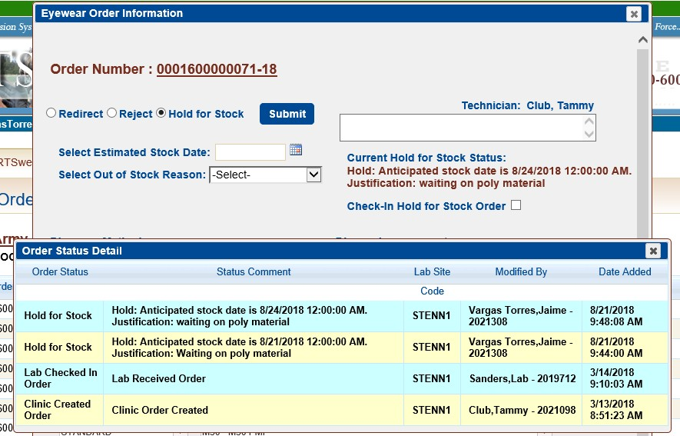

When the anticipated stock is received the lab tech checks the Check in Hold for Stock Order and the order goes back to the Dispense file.

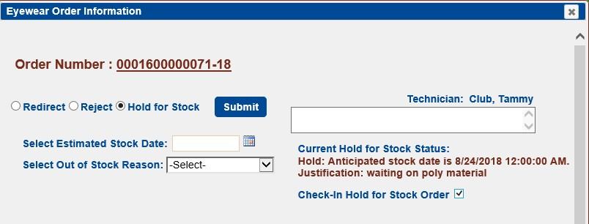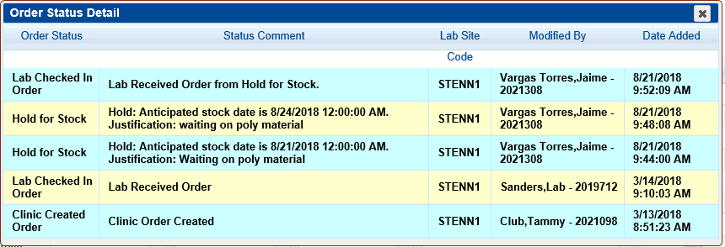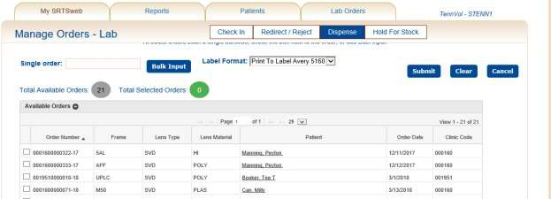

**Multiple Orders**: After checking in the orders the user has the ability to **Redirect or Reject multiple** orders.

Click on Redirect/Reject sub-TAB

A list of checked-in orders will be displayed.

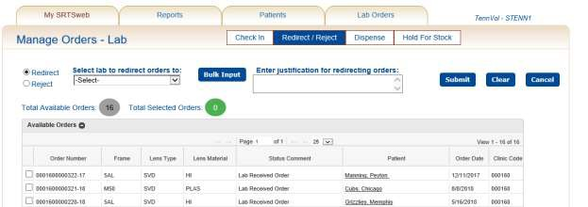

Select Redirect radio button.

Go to ‘Select Lab to redirect orders to’ and click on the drop-down arrow

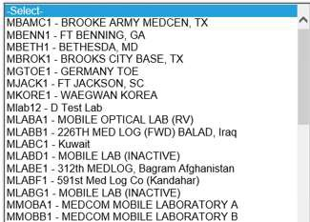

A list of Labs will be displayed.

Select the Lab to redirect orders to.

A message displays indicating a Justification is required. Enter justification.

## NOTE: The justification must be at least five (5) characters in length.

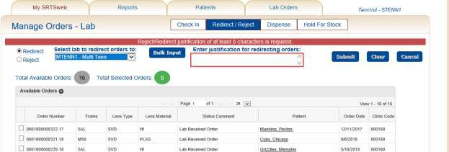

Click on Bulk Input.

The Bulk Order Input screen displays.

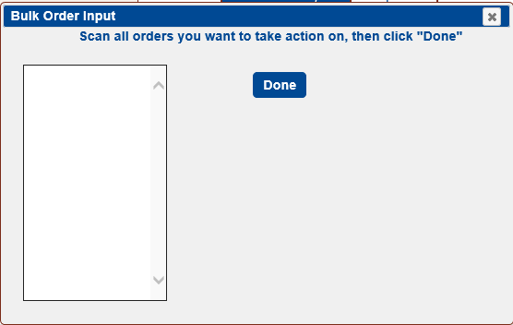

Scan-in or manually type-in the order numbers and click ‘Done’ when finished.

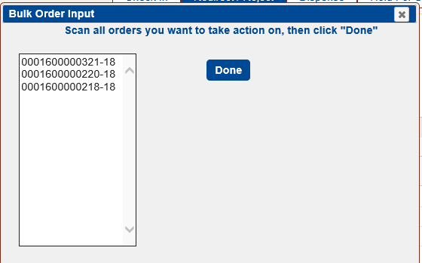

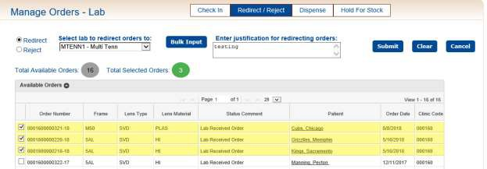

Submit selected order numbers

## NOTE: If incorrect Lab is chosen (i.e. a multivision order is redirected to a single vision Lab) a message is displayed: “Multivision orders cannot be sent to single vision Labs. Please select a different Lab”.

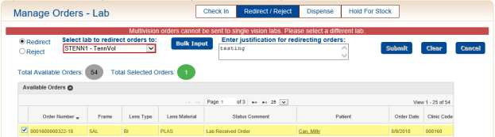

To **Reject** multiple orders:

Click on Redirect/Reject sub-TAB

A list of checked-in orders will be displayed.



Select Reject radio button.

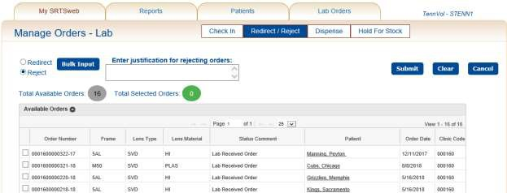

Click on Bulk Input.

The Bulk Order Input screen displays.



Scan-in or manually type-in the order numbers and click ‘Done’ when finished.



Go to ‘Enter justification for rejecting orders’ comment box and enter justification.

## NOTE: The justification must be at least five (5) characters in length.

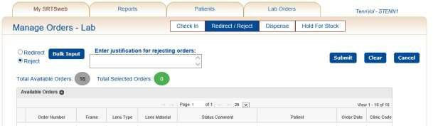

Submit selected order numbers

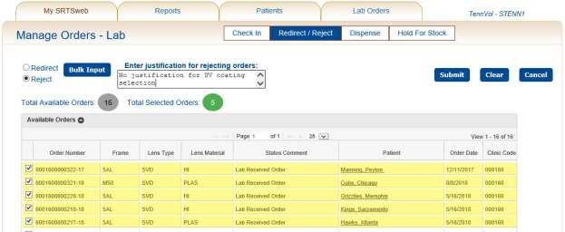

# Manage Orders – Check-Out

The production of the order is considered complete when the order has successfully passed the quality control checks. The order is then ready to be dispensed or checked- out to either the clinic that created the order or mailed directly to the patient.

When the **Lab Orders -> Lab Order Check-Out** process is selected, the system will display the Manage Lab Orders – **Dispense Orders** screen.

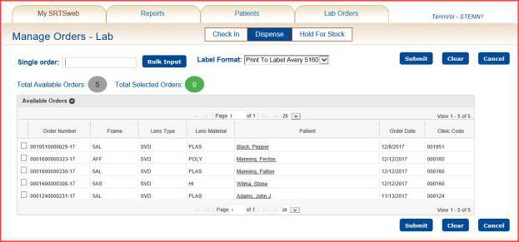

On this screen the user has the option of scanning an order barcode, doing a bulk input, entering the order number manually or selecting the order(s) to dispense from the list of orders displayed.

The system will total the record counts and update the screen display with the new number of orders available for check-out. Total Selected Orders will update as order number is selected.

After scanning press **Done**. The screen will display the orders with a checked box.

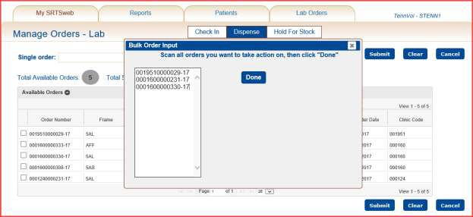

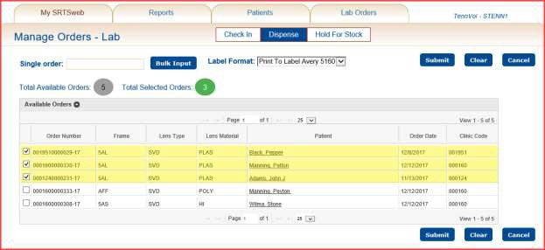

When the order record selections are complete, clicking on the **Submit** button cause the SRTSweb system to mark the order(s) as dispensed.

If the order is a lab mail to patient select the Label Format for **Print to Label Avery 5160** or **Print to Single Label.**

The status will be sent back to the appropriate clinic.

The screen will display a list of addresses to be saved and printed and mailed to the appropriate address.

The Lab Admin can set a preference to have the labels sort alphabetically. The screen will display a screen to be Open, Save or Save and Open.

**NOTE:** The user can reprint the mailing labels from the Reports - Manage Reports – Reprint Shipping Labels for the past 7 days if the lab ships to patients.

**NOTE:** Only if the lab is a ship to patient lab.



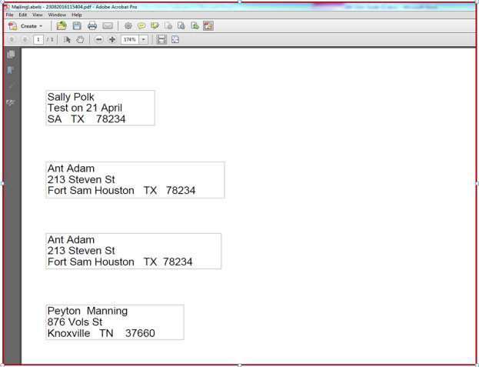

# Manage Orders – Hold for Stock

The user has the ability to view and modify the status of all orders that are ready to be checked in, ready for dispense or on hold in the lab.

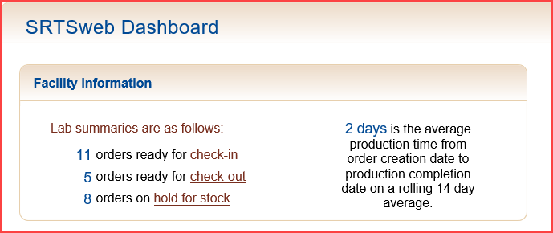

The user has the capability of releasing the items **Hold for Stock** by checking the

**Release** box.

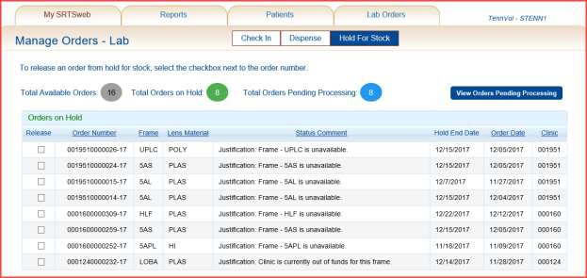

Once the Release box is checked the user will receive a note to **Select All** or only one checked. Pressing **No** will release only the one checked.

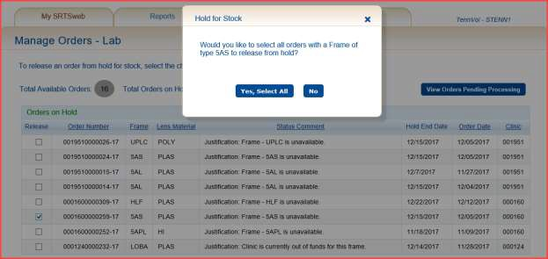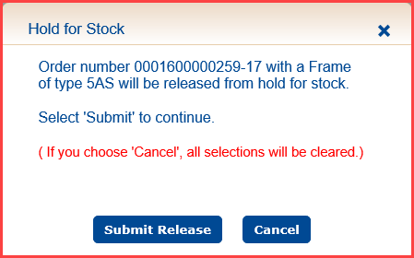

Order is ready for Dispense.

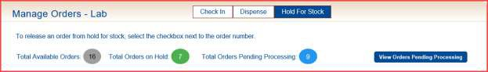

The user has the option of pressing the **View Orders Pending Processing** to view all orders that have been created by clinic not checked in and orders received by lab.

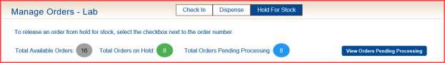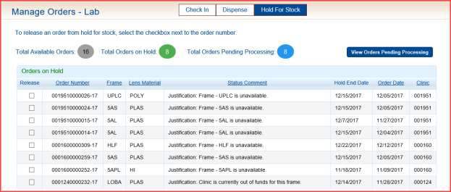

The orders pending processing can be put Hold for Stock also.

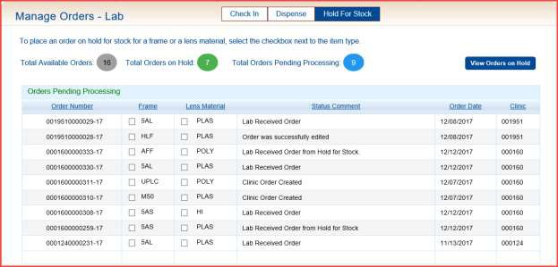

# Reports

**Manage Reports**

From the SRTSweb Dashboard screen, select Reports -> Manage Report.

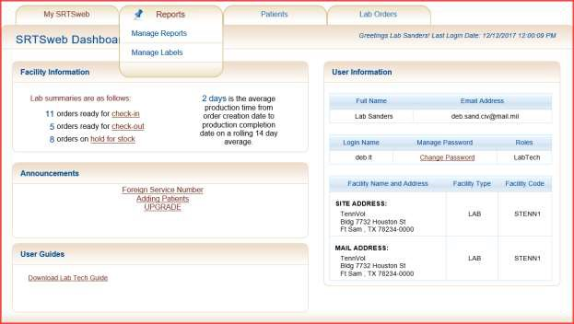

Selecting this option displays the Reports -> Manage Reports –>View Reports screen.

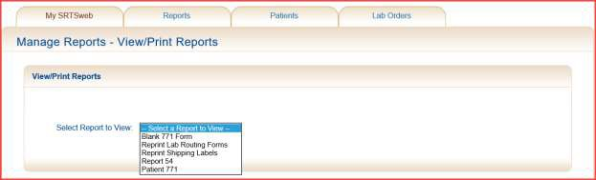

The user may select a report to view from the drop down menu provided. The Lab module of SRTSweb may produce the following reports:

* Blank DD Form 771
* Reprint Lab Routing Forms
* Reprint Shipping Labels
* Report 54
* Patient 771

## Blank DD Form 771

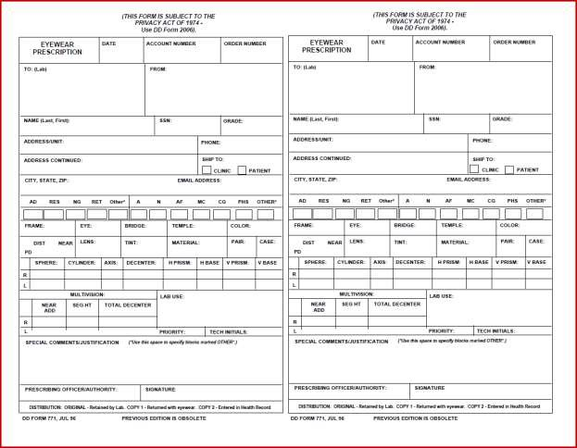

**Reprint Lab Routing Forms**



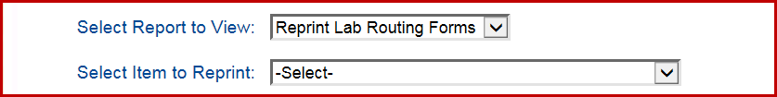

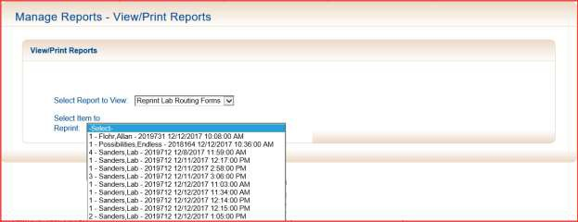

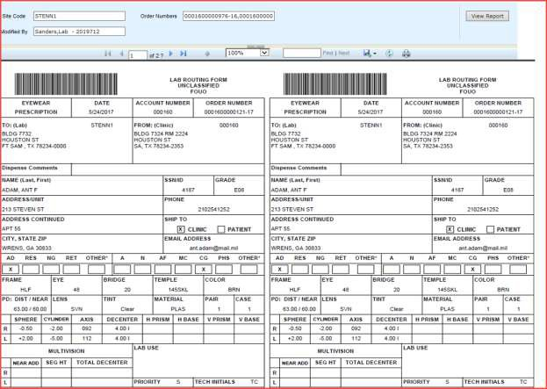

**Reprint Shipping Labels**

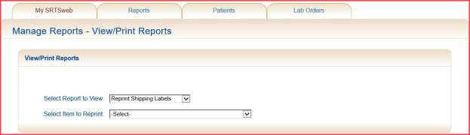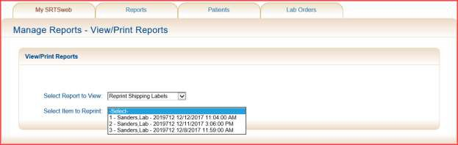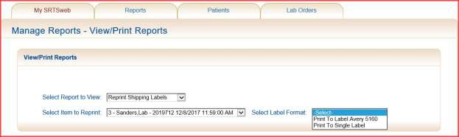

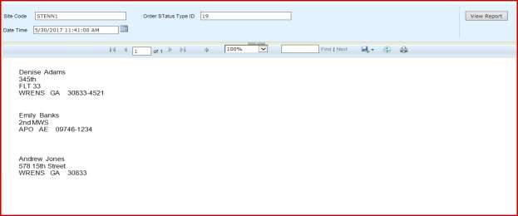

**Report 54**

The user is prompted to enter a date range by either typing in date values or selecting the dates from calendars.

Press View Report.

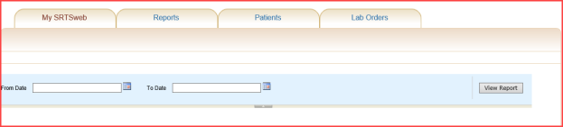

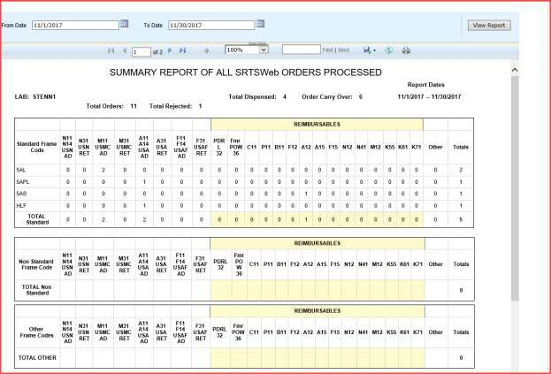

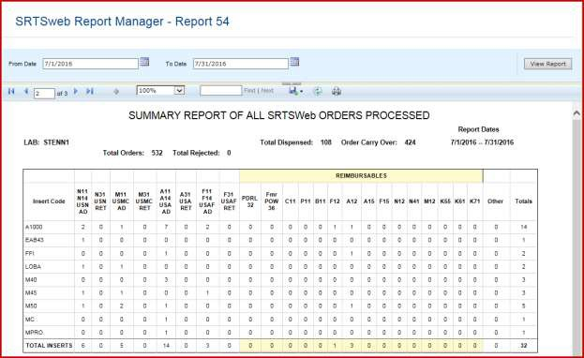

To print, save or email, select the Export drop down menu. Select the format.

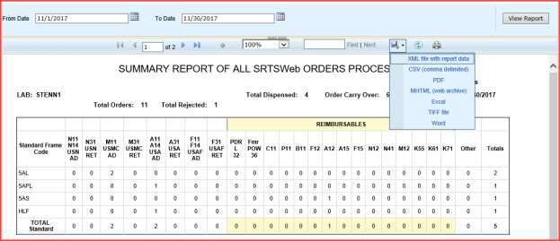



## Patient 771

To search for all DD-771 click the NULL button. To search for one type in OrderNbr.

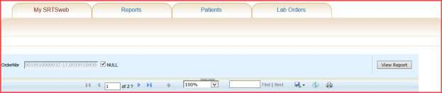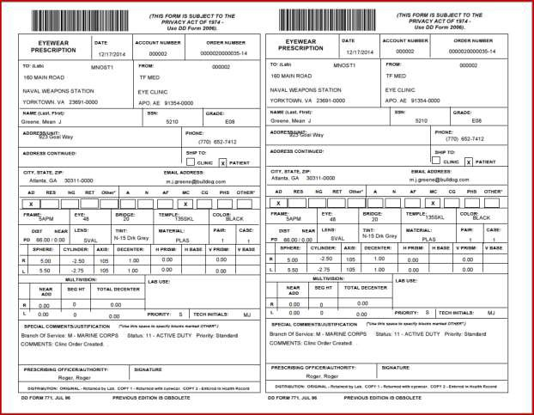

# Manage Labels

**NOTE: Labels must be printed before they are saved in History.**

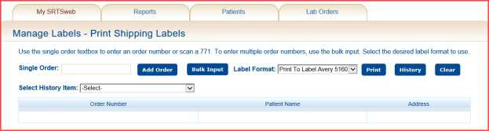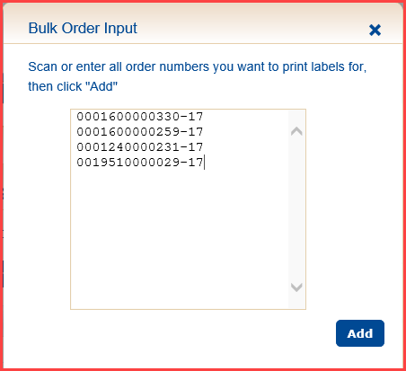

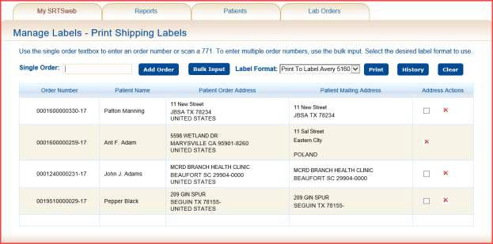

Press History.

